


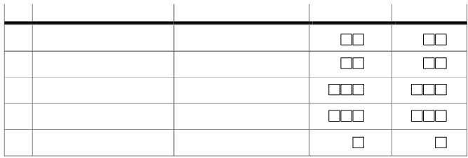

no

Carbon copies for :
1. BPS District/City
2. Rural village/ Urban village

REPUBLIC OF INDONESIA
CENTRAL STATISTICS AGENCY

AGRICULTURAL CENSUS 2003

POTENTIAL OF RURAL VILLAGE/URBAN VILLAGE
Confidential ST2003-PODES

I. LOCATION IDENTIFICATION

NO. DETAIL June 2002

101 Province

New Change Identity

102 District/City *)

103 Subdistrict

104 Rural village/urban village/UPT/PMT*)

105 Location Urban - 1 Rural - 2

II. OFFICER NOTES

NO. DETAIL ENUMERATOR SUPERVISOR

201 Name of Officer

202 NIP

203 Date of Admission/Inspection

204 Signature

*) cross out whichever does not apply
…………………, ………………… 2002

Head of rural village/urban village/UPT/PMT

Name and position

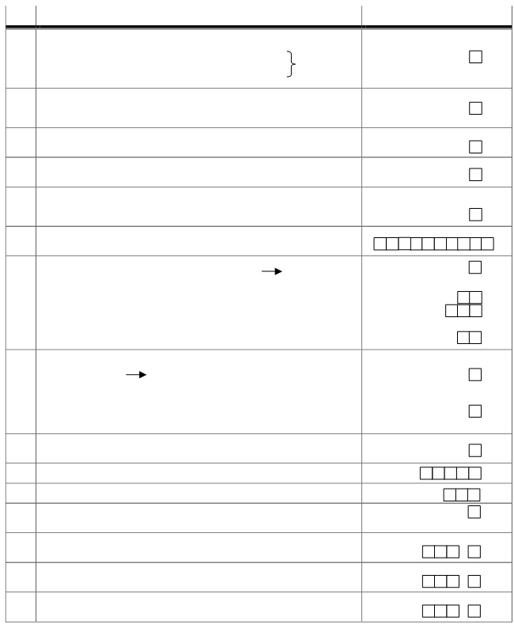

III. GENERAL INFORMATION VILLAGE/SUB-DISTRICT

NO. DESCRIPTION CODE

301 Legal status rural/urban village
Definitive - 1 UPT - 3
To P306
Preparation - 2 PMT - 4

302 If P301 Code "1", Classification rural /urban village
Self-help - 1 Self-sufficiency - 3
Self-developing - 2

303 If P301 Code "1" or "2", status of administration rural /urban village
Urban village - 1 Rural village - 2

304 Any rural village Representative Body/urban village Committee?
Yes - 1 No - 2

305 Category Urban/Rural Resilience Organization (LKMD/K) or Rural/Urban Village Development Body (LPMD/K)
Preparatory - 0 Category 2 - 2
Category 1 - 1 Category 3 - 3
(to be filled by officer)
306 If P301 "Code 2, 3, or 4", put name of district and main village/location
District: …………………………, Rural/Urban: …………………………….

307 a. Any Neighborhood Unit (RT)/Community Unit (RW): Yes -1 No - 2 P307c

b. If yes, put the number
1) Kampong Unit/ Community Unit ….. RK/RW
2) Neighborhood Unit ….. RT

c. Name of local community unit (SLS)
other than RT/RW: …………………………………………………………………

308 a. Geographic location of rural/urban village
Coastal - 1 P309 Non Coastal - 2

b. If “non coastal” “:
- Valley/watershed area - 1
- Slope/ridge - 2
- Plateau - 3

309 Topography rural/urban
Flat - 1 Hilly - 2

310 The altitude of rural/urban village from sea level ………... m

311 average depth of ground water source (artesian well) ……….… m

312 Any specific building for rural/urban village office?
: Yes - 1 No - 2

313 Distance from rural/urban village office to sub-district office …..…... km

314 Distance from rural/urban village office to district/city office ..……... km

315 Distance from rural/urban village office
to nearest other district/city ...…….. km

,

,

,

1

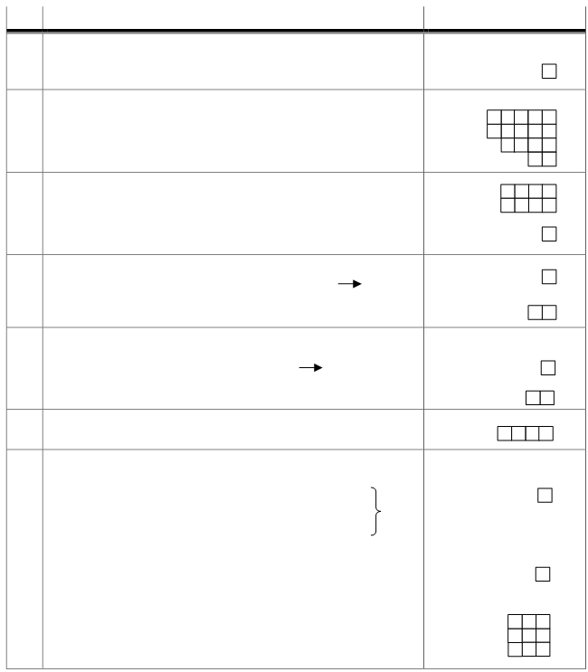

IV. CITIZENSHIP AND EMPLOYEMENT

NO. DESCRIPTION CODE

401 Registration of birth, death and migration
No - 1 Yes, organized - 3
Yes, but disorganized - 2

402 Population and family
a. Number of men ……… persons
b. Number of women ……… persons
c. Number of families ………….. families
d. Number of farming families (%) ……… percent

403 a. Number of Pre-Prosperous and Prosperous I Families: ………….. families
Condition in year: …………..

b. Number of Pre-Prosperous and Prosperous Families dcompared to condition in previous year:
More - 1 Less - 3
Similar - 2 Unclear - 4

404 a. Any members of this ural/urban village move out to work/study:
Yes - 1 No - 2 P405
b. If “Tes” where do they work/study:
Abroad - 1 Other District/City - 4
Other Province - 2 Other Rural/Urban Village - 8

405 a. Any resident non citizen of rural/urban village
Work/study in this rural/urban village
Yes - 1 No - 2 P406
b. If “Yes” where they originate:
Abroad - 1 Other District/City - 4
Other Province - 2 OtherRural/Urban Village - 8

406 Number of rural/urban village citizens with no job
(unemployed) …….. people

407 a. Main income of major population
Agriculture - 1
Mining and drilling - 2
Manufacturing industry - 3
Bulk/retail business, restaurant, accommodation - 4 Blok V
Services - 5
Others - 6
b. If P407a code "1", most population work at which sector:
Rice/crops - 1 land fisheries - 4 Forestry - 7
Horticulture - 2 sea fisheries - 5 Agriculture
Plantation - 3 Farming - 6 Others - 8

c. If P407b ≠ Code "5 or 8", percentage of workers in agriculture land:
(1) Owner and cultivator ..… percent
(2) Cultivator ..… percent
(3) Labor ..… percent

2

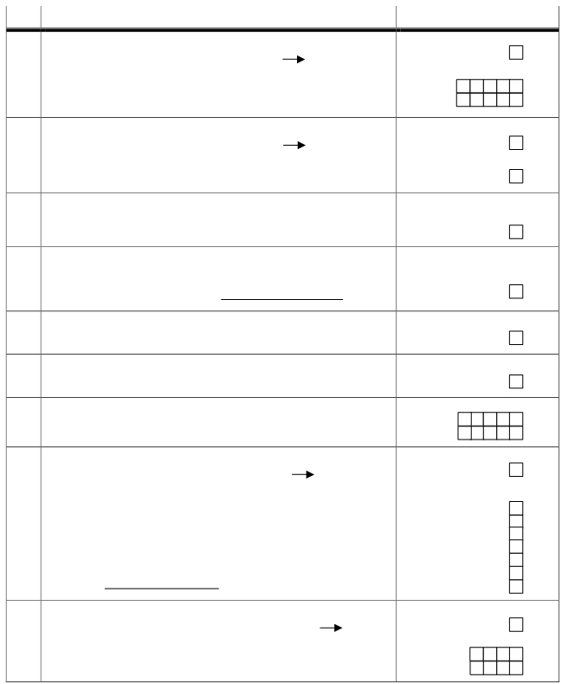

V. HOUSING AND ENVIRONMENT

NO. DESCRIPTION CODE

501 a. Any families with electricity:
Yes - 1 No - 2 P502
b. Number of families with electricity
1. State-owned power company (PLN) ………….. families
2. Non-PLN ……….…. families

502 a. Any lighting for rural/urban village main road
Yes - 1 No - 2 P503
b. If "yes", type: Provided by government - 1
Provided by non-government - 2
Non-electricity - 3

503 Fuel used by family to cook
:
Gas/LPG - 1 Firewood - 3
Kerosene - 2 Others( coal, charcoal, etc) - 4

504 Waste dump for family :
,
Take out - 1 River - 3
In ground /burn - 2 Others - 4
(Tuliskan)

505 Latrine for family
Own - 1 Public - 3
Communal - 2 Non-latrine - 4

506 Condition of grey/black water piping
Smooth - 1 Inundated - 3
Clogged - 2 No-piping - 4

507 Number of houses according to quality
a. Permanent ...…… unit
b. Non-permanent ..……. unit

508 a. Any river runs through this rural/urban village?
Yes - 1 No - 2 P510

b. If "Ada", water from river is used for
1) Bathing/washing Yes - 1 No - 2
2) Drinking Yes - 1 No - 2
3) Purified for drinking Yes - 1 No - 2
4) Irrigation Yes - 1 No - 2
5) For industry/factory Yes - 1 No - 2
6) Transportation Yes - 1 No - 2
7) Others Yes - 1 No - 2
(Specify down)

509 a. Families living in riverbanks
Yes - 1 No - 2 P510

b. If "Yes”
1) Number of families …… … families
2) Number of houses ……….… unit

3

NO. DESCRIPTION CODE

510 a. Families living under high-voltage powerlines (> 500 KV)
Yes - 1 No - 2 to P511a
No high voltage powerlines - 3
b. If "Yes"
1) Number of families ………..… Families
2) Number of houses ……….…. unit

511 a. Slums: Yes - 1 No - 2 P512a
b. If “Yes”,
1) Number of locations .……..…. location
2) Area …..…….. Ha ,
3) Number of houses ……… unit
4) Number of families ……….… Families

512 a. Manufacture industry: Yes - 1 No - 2 P513
b. If "yes”, the waste is dumped to:
Waste Dump Installation (IPL) - 1 River - 3
Ground - 2 Others - 4
(Specify)

513 Environmental problems in the last one year
If column (2) code 1, complain to
Type of problems Yes - 1 No - 2 head of village/Lurah
Yes - 1 No - 2
(1) (2) (3)
a. Water pollution
b. Soil pollution
c. Air pollution
d. lack of green area
e. Noise pollution

514 natural disaster in the last 3 years
If column (2) code 1,
Type of disaster Yes - 1 No - 2 number of occurrence
(1) (2) (3)
a. Earthquake
b. Landslide
c. flood

515 a. Is this rural/urban village prone to earthquake:
Yes - 1 No - 2
b. is this rural/urban village prone to:
1) Landslide Yes - 1 No - 2
2) if "Yes", how many families living in the area .… Families
c. Is this rural/urban village prone to:
1) Flood Yes - 1 No - 2
2) If "Yes", how many families living in the location..… families
d. Is this rural/urban village prone to natural disaster:
1) Others Yes - 1 No - 2
(Specify)
2) Bila "Yes", how many families living in the location..… families

516 a. Is there anyone in this rural/urban village living in protected area?
(natural, cultural preservation area, wildlife, protected forest):
Yes - 1 No - 2 P517
b. If "Yes", how many families ..…. Families

4

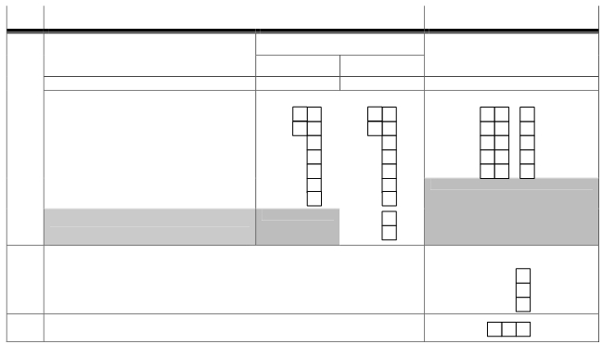
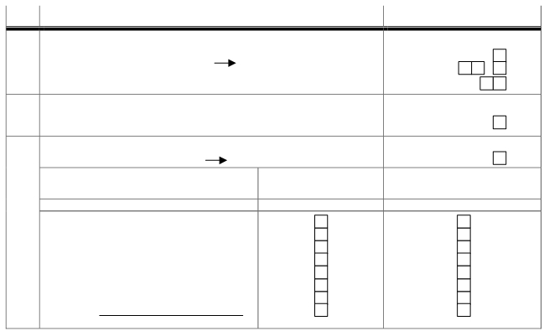

NO.

517 a. Is there any critical land:
Yes - 1 No
b. If “Yes” how big?
c. Number of families

DESCRIPTION CODE

- 2 P518
,
..... ha
..... keluarga

518 Is the rural/urban village located within/at the side of/outside of the forest.

Within the forest - 1 At the side of - 2 Outside of - 3

519 a. Is there mining/drilling business in the rural/urban village?
Yes - 1 No - 2 B.VI

If Column (2) Code 1

b. Types of mining/drilling material Yes - 1 has it been exploited

No - 2 Yes - 1 Not yet - 2

(1) (2) (3)

1) Stone/coral
2) Sand
3) Limestone
4) Sulfur
5) Kaolinite
6) quartz-sand
7) clay
8) Others
(Specify)

VI. EDUCATION

NO.

601 Education

DESCRIPTION
Number of Schools
State Private

CODE

If any, distance to nearest school (km)

(1) (2) (3) (4)

a. Kindergartens ,

b. Elementary School (SD) and equivalent ,

c. Junior Highschool (SLTP) and equivalent ,

d. Senior highschool (SMU) and equivalent ,

e. Vocational school (SMK) ,

f. Academy/university and equivalent

g. School for disabled

h. Islamic boarding school/Islamic school

i. Seminary or equivalent

602 This rural/urban village has Kejar Paket (equivalent education program) :
a. Kejar paket A PBH Yes - 1 No - 2
b. Kejar paket A equivalent to SD Yes - 1 No - 2
c. Kejar paket B equivalent to SLTP Yes - 1 No - 2

603 Number of drop-out students from SD ……. Students

5

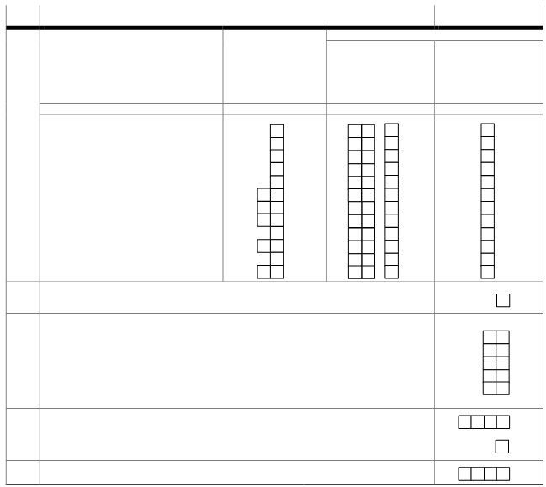


NO. DESCRIPTION CODE

604 Training school in the rural/urban village
If column (2) Code 1,
Type of skill Yes - 1 No - 2 Number
(1) (2) (3)
a. Language
b. Accounting
c. computing
d. Cooking/culinary
e. Sewing/ fashion
f. Beauty
g. Mechanics
h. Electronic

VII. HEALTH, NUTRITION, AND FAMILY PLANNING

NO. DESCRIPTION CODE

If answer is “no” or column 2 = "0"
701 Health facility Number Distance from rural/ How to reach facility
Of urban village to health :
Facility facility (km) Very easy - 1
Easy - 2
Difficult - 3
Very difficult - 4
(1) (2) (3) (4)

a. Hospital ,
b. Maternity Hospital/maternity Clinic ,
c. Policlinic/Health Post ,
d. Health Clinic ,
e. Supporting Health Clinic ,
f. Private practice ,
g. Midwife Practice ,
h. Health Post ,
i. Village Maternity Clinic ,
j. Pharmacy ,
k. Village Medication ,
l. Traditional Drug Store ,

702 Do the rural/urban village have regular health visit by the health post?
Yes - 1 No - 2

703 Medical practitioner lives in this rural/urban village:
a. 1. Male doctor ………… orang
2. Female doctor ………… orang
b. 1. Midwife ………… orang
2. Village midwife (stationed according to placement letter) ………… orang
c. 1. Trained traditional midwife ………… orang
2. Non-trained traditional midwife ………… orang

704 a. Number of reference letter for impoverished families released by rural/urban village: ……….… surat
b. Number of reference letter released, compared to last year
More - 1 Same number - 2 Less - 3

705 Number of families received health card in the past one year : ..…… families

6



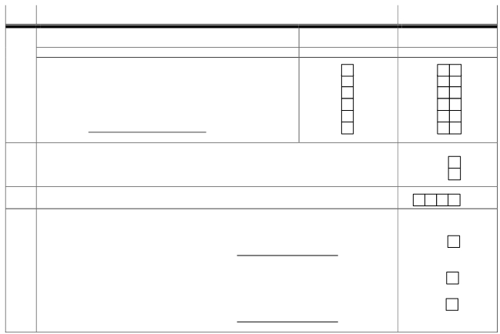
NO. DESCRIPTION CODE
Yes - 1 Number of death
706 Epidemic disease for the past one year No - 2 (If column (2) = 1)
(1) (2) (3)
a. Diarrhea
b. Dengue fever
c. Acute Upper Respiratory Infection
d. Measles
e. Malaria
f. Others
(Specify)

707 Is there malnutrition cases in this rural/urban village?
a. Balita (under 5): Many - 1 Few - 2 None - 3
b. Other than balita : Many - 1 Few - 2 None - 3

708 Number of family planning participants: ... people

709 a. The source for drinking/cooking from
Water company/Mineral water - 1 River/lake - 5
Electric/hand pump - 2 rain water - 6
Artesian well - 3 Others - 7
Spring water - 4 (Specify)

b. Do most of population in this rural/urban village buy drinking water:
Yes - 1 No - 2

c. Water fro bathing/washing obtained from
Water company - 1 River/lake - 5
Electric/hand pump - 2 Rain water - 6
Artesan well - 3 Others - 7
Spring water - 4 (Tuliskan)

VIII. SOCIAL CULTURE

NO. DESCRIPTION NUMBER

801 Number of worship place
a. Mosque …….…. unit
b. Small mosque …….…. unit
c. Christian church …….…. unit
d. Catholic church …….…. unit
e. Temple …….…. unit
f. Vihara …….…. unit
g. Chinese temple .…… unit

802 Social/community activities

a. Social institution activities
1. Scout Yes - 1 No - 2
2. Youth center Yes - 1 No - 2
3. Family Skills Education Yes - 1 No - 2
4. Religious communities Yes - 1 No - 2
5. Orphanage Yes - 1 No - 2
6. Elderly home Yes - 1 No - 2
7. House for disabled Yes - 1 No - 2

b. Community activities
1. Social gathering Yes - 1 No - 2
2. communal works Yes - 1 No - 2
3. Islamic charity Yes - 1 No - 2

7

NO. DESCRIPTION CODE

c. Social activities by farmers organization
1. Association of Farmers Using Water (P3A) Yes - 1 No - 2
2. Farmers Group Yes - 1 No - 2
3. Fishermen Group Yes - 1 No - 2
4. Young Farmers Group Yes - 1 No - 2
5. Farming Counseling Yes - 1 No - 2
6. Cattle Farmers Group Yes - 1 No - 2
803 People with disabilities
Number of those staying Number staying at care center
Description at home
(1) (2) (3)
a. Blind
b. Deaf-mute
c. Mental retardation
d. Physical disability
e. Double disability

804 Number of library: .……… unit

805 Community Organizations in this rural/urban village
Type of organization Existence activities
(1) (2) (3)
a. Environmental Yes - 1 No - 2 Yes - 1 No - 2
b. Women Yes - 1 No - 2 Yes - 1 No - 2
c. Children Yes - 1 No - 2 Yes - 1 No - 2
d. Law and human rights Yes - 1 No - 2 Yes - 1 No - 2
e. Others Yes - 1 No - 2 Yes - 1 No - 2
(Specify)

806 What are religious/faith believers in this rural/urban:
Islam - 1 Christian - 2 Catholic - 4
Hinduism- 8 Buddhism - 16 Konghucu - 32 Others - 64

807 Majority believers in this rural/urban village :
Islam - 1 Christian - 2 Catholic - 3
Hinduism- 4 Buddhism - 5 Konghucu - 6 Others - 7

808 Is there a faith group in this rural/urban village?:
Yes - 1 No - 2

809 Is there more than one ethnicity in this rural/urban village?
Yes - 1 No - 2

810 The major ethnicity in this rural/urban village is: …………………………
(specified by BPS DIstrict/City)

811 Is there any interracial marriage in this rural/urban village?
Yes - 1 No - 2

812 Is there an indigenous organization in this rural/urban village:
Yes - 1 No - 2

813 Historical site/building
a. Building Yes - 1 No - 2
b. Bridge Yes - 1 No - 2
c.Temple Yes - 1 No - 2
d.Port Yes - 1 No - 2
e. Station Yes - 1 No - 2
f. Spiritual place (e.g.: old mosque, bathhouse) Yes - 1 No - 2
g.Others Yes - 1 No - 2
(Specify)
8

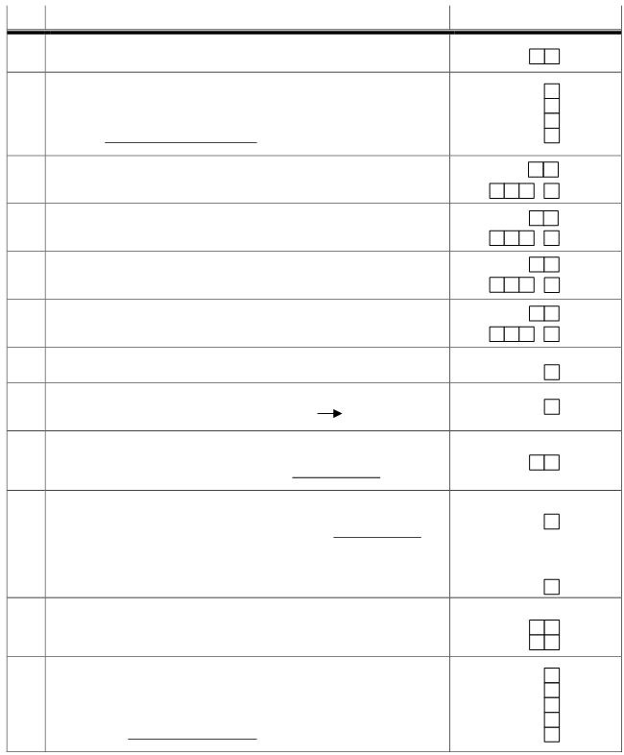

IX. RECREATION, ENTERTAINMENT, ART AND SPORT

NO. DESCRIPTION CODE

901 Open space/square/playground: ..…. unit

902 Recreational place (commercial)
a. Natural : 1. Sea : ..…. unit
2. Non-Sea : ..…. unit
b. Culture : ..…. unit
c. Others : ..…. unit
(Specify)

903 a. Cinema: ..…. unit
b. If “no" (the answer=0),
Distance to the nearest cinema .…... km ,

904 a. Video/VCD/DVD/LD rental: ..…. unit
b. If “no” (the answer=0), ,
Distance to nearest Video/VCD/DVD/LD rental .…... km

905 a. Pool house: ..…. unit
b. If “no” (the answer=0)", ,
Distance to the nearest pool house .…... km

906 a. Pub/discotheque/karaoke: ..…. unit
b. If “No (the answer is =0)", ,
Distance to the nearest pub/discotheque/karaoke .…... km

907 Is there place for in this rural/urban village?:
Yes - 1 No - 2

908 Is this rural/urban village has art organization?:
Yes - 1 No - 2 P911

909 Type of art managed (can be more than 1):
Music - 1 fine art - 4 Puppetry - 16
Dance - 2 Theater - 8 Others - 32
(Specify)

910 a. The main “art”:
Music - 1 Fine art - 3 Puppetry - 5
Dance - 2 Theater - 4 Others - 6
(Specify)

b. Is this art performance group/organization is paid for their show?
:
Yes - 1 No - 2

911 Traditional game and folklore in this rural/urban village
a. Number of existing traditional game: …... game
b. Number of familiar folklore: …… story

912 venue for art and culture activities:
a. Cultural park Yes - 1 No - 2
b. Art center Yes - 1 No - 2
c. Galery Yes - 1 No - 2
d. Cultural community Yes - 1 No - 2
e. Others Yes - 1 No - 2
(specify)

9

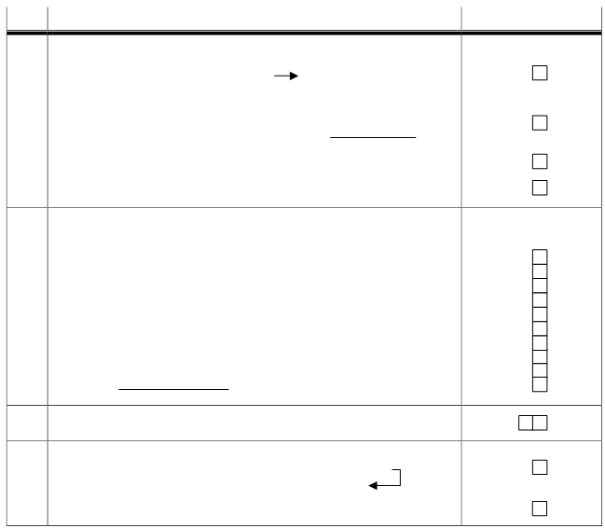
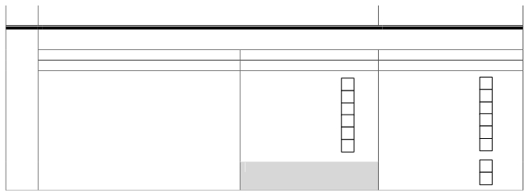

NO. DESCRIPTION CODE

913 Sport
Type of Sport Field Activity Group
(1) (2) (3)

a. Football Yes - 1 No - 2 Yes - 1 No - 2
b. Volley ball Yes - 1 No - 2 Yes - 1 No - 2
c. Badminton Yes - 1 No - 2 Yes - 1 No - 2
d. Basket ball Yes - 1 No - 2 Yes - 1 No - 2
e. Tennis Yes - 1 No - 2 Yes - 1 No - 2
f. Swimming Yes - 1 No - 2 Yes - 1 No - 2

g. Table tennis Yes - 1 No - 2
h. Martial art (pencak silat, karate, etc) Yes - 1 No - 2

X. TRANSPORTATION

NO. DESCRIPTION CODE

1001 Type of inter urban/rural village transportation

a. Most inter rural/urban village transportation by
Land - 1 Water - 2 P1001c

b. If mostly by land (P1001a ="1")

1. Type of surface for the longest road
Asphaltal - 1 Soil - 3
Cemented (stone, gravel, etc) , - 2 Others - 4
(specify)

2. Can 4-wheeled vehicle drive through it all year long
: Yes - 1 No - 2

c. made of logs: Yes - 1 No - 2

1002 Type of public transportation used by community to nearest sub-district/city

01 Bicycle taxi Yes - 1 No - 2
02 Tri-cycle Yes - 1 No - 2
03 cart/horsecart Yes - 1 No - 2
04 Motorcycle taxi Yes - 1 No - 2
05 tri-motorcycle Yes - 1 No - 2
06 vehicle ≥ 4 Yes - 1 No - 2
07 boat Yes - 1 No - 2
08 Motorboat Yes - 1 No - 2
09 Motorship Yes - 1 No - 2
10 Others Yes - 1 No - 2
(specify)

1003 From all public transportations in P1002, the main transportation is
…………………………………….… (put code from P1002 in the box)

1004 a. Bridge over river through which 4-wheeled vehicle pass
Yes - 1 No - 2

P1005

b. If "Yes" made of: Steel/concrete - 1 Steel/concrete and
wood/bamboo - 2 wood/bamboo - 3

10

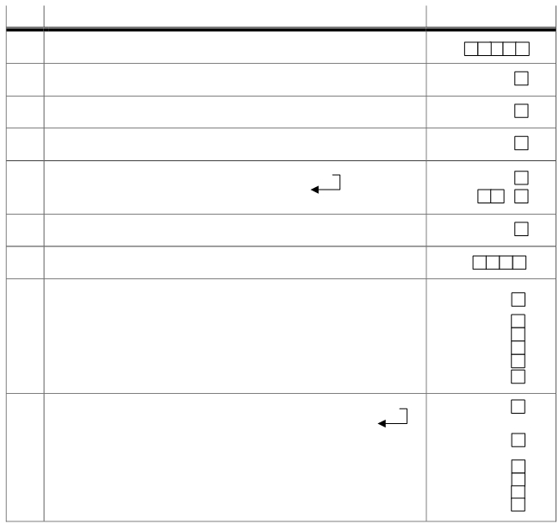
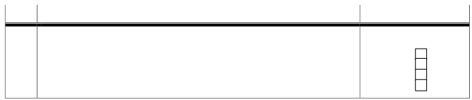

NO. DESCRIPTION CODE

1005 Public transportation infrastructure in this rural/urban village
a. 4-wheeled vehicle terminal Yes - 1 No - 2
b. Train station Yes - 1 No - 2
c. Port Yes - 1 No - 2
d. Airport Yes - 1 No - 2

XI. COMMUNICATION AND INFORMATION

NO. DESCRIPTION CODE

1101 Number of families subscribing to telephone service: ……….….. families

1102 Coin/c ard phonebooth: Yes - 1 No - 2

1103 Communication kiosk: ……... unit

1104 Internet kiosk (Warnet) : ….….. unit

1105 a. Post office: Yes - 1 No - 2

P1106
b. If " No", distance to nearest post office: ……….. km ,

1106 Mobile post: Yes - 1 No - 2

1107 Number of families own TV set: …...…….. families

1108 TV channels broadcast received in this rural/urban village
a. TVRI Yes - 1 No - 2

b. private TV Swasta, including:
1. TPI Yes - 1 No - 2
2. RCTI Yes - 1 No - 2
3. SCTV Yes - 1 No - 2
4. INDOSIAR Yes - 1 No - 2
c. Foreign broadcast Yes - 1 No - 2

1109 a. Newspaper subscribers in this rural/urban village Yes - 1 No - 2
P1109c
b. If “yes”, types of newspapers:
Local - 1 National -2 Local and National - 3

c. Magazine/tabloid circulated in this urban/rural village:
1. Politics Yes - 1 No - 2
2. Religion Yes - 1 No - 2
3. Lifestyle Yes - 1 No - 2
4. Others Yes - 1 No - 2

11

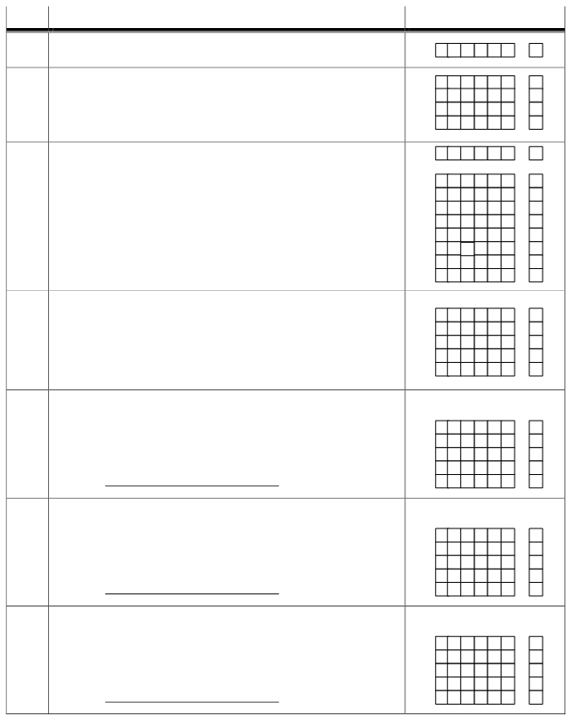

XII. LAND USE AND OWENERSHIP

AREA
NO. DESCRIPTION (Ha)

1201 Area of rural/urban village (P1202 + P1203) ……….. ha ,

1202 Area of rice field (a + b + c) ……….. ha
a. Cultivated irrigated land ……….. ha
b. Cultivated non-irrigated land ……….. ha
c. Temporary non-cultivated land ……….. ha

,
,
,
,
,

,

1203 area of non-rice field land (a + b + c + d + e + f + g+ h) ……….. ha
a. field/fishpond/pasture ……….. ha
b. Plantation ……….. ha
c. People’s forest ……….. ha
d. Housing and settlement ……….. ha
e. Area for industrial infrastructure ……….. ha
f. Area for other buildings (office, shops) ……….. ha
g. Others (excluding state forest) ……….. ha
h. Temporary non cultivated rice field ……….. ha

,
,
,
,
,
,
,
,

1204 Part of rural/urban village which is ,

a. Village land (customary land, communal land, etc) ……….. ha ,

b. Native land ……….. ha ,

c. Personally owned land with certificate ……….. ha ,

d. Personally owned land without certificate ……….. ha ,

e. Charity land ……….. ha

1205 Change in land use in the last 3 years, rice field turned to :
a. Non-agriculture land ……….. ha
b. Housing ……….. ha
c. Industry ……….. ha
d. Business/office ……….. ha
e. Others ……….. ha
(Specify)

1206 Change in land use in the last 3 years,
Field/cultivation area turned into:
a. Rice field ……….. ha
b. Housing ……….. ha
c. Industry ……….. ha
d. Business/office ……….. ha
e. Others ……….. ha
(specify)

1207 Change in land use in the last 3 years
Dam/pool/fishpond turned into
a. Rice field ……….. ha
b. Housing ……….. ha
c. Industry ……….. ha
d. Business/office ……….. ha
e. Others ……….. ha
(specify)

,
,
,
,
,

,
,
,
,
,

,
,
,
,
,

12

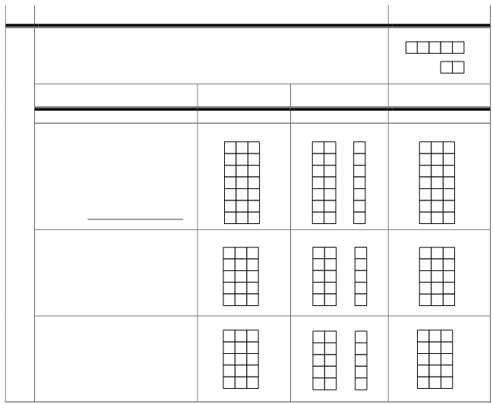
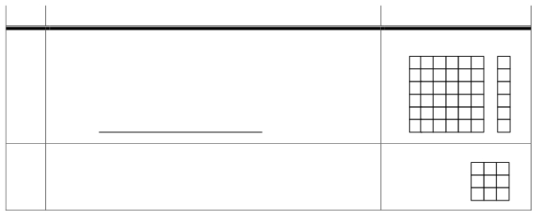

NO. DESCRIPTION

1208 Change in land use in the last 3 years
Forest turned into
a. Rice field
b. Housing
c. Industry
d. Business/office
e. Non-rice field cultivation land
f. Others
(Specify)

NUMBER

,
……….. ha
,
……….. ha
,
……….. ha ,
……….. ha
,
……….. ha
,
……….. ha

1209 Percentage of cultivation land in rural/urban village owned by:

a. Owner (including non-residents) ……….. persen

b. Owner and cultivator ……….. persen

c. Cultivator/tenant ……….. persen

XIII. AGRICULTURE

NO. DESCRIPTION NUMBER

1301 A. Potentials from “food, medication and decorative plants” in the last one year.
1. Number of food plant farming families ………… families
2. Number of food plant farming businesses ………… companies

Type of plants
(1)

CODE
(2)
AREA
(Ha)
(3)
PRODUCTION
(Ton)
(4)

B. Rice and crops

1. Rice
2. Corn
3. Soybeans
4. Cassava
5. Yams
6. Groundnuts
7. Others
(Specify)
,
,
,
,
,
,
,

C. Vegetables

1. …………………………………….. ,

2. …………………………………….. ,

3. …………………………………….. ,

4. …………………………………….. ,

5. …………………………………….. ,

D. Fruits
1. ……………………………………..
2. ……………………………………..
3. ……………………………………..
4. ……………………………………..
5. ……………………………………..

,
,
,
,
,

13

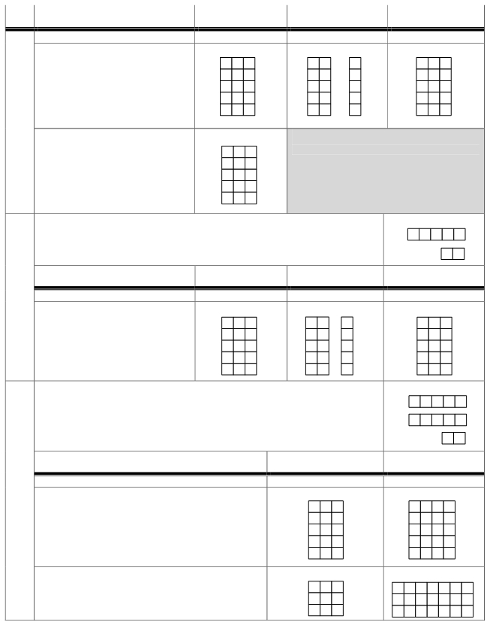

NO. TYPE OF PLANTS CODE
(1) (2)

AREA PRODUCTION
(Ha) (Ton)
(3) (4)

E. Medication

,

1. ……………………………………..

2. …………………………………….. ,

3. …………………………………….. ,

4. …………………………………….. ,

5. …………………………………….. ,

F. Decorative plants
1. …………………………………….
2. …………………………………….
3. …………………………………….
4. …………………………………….
5. …………………………………….

1302 A. Potentials in “plantation” in rural/urban village in the past one year
1. Number of plantation farming families ………... families

2. Number of plantation businesses ………... companies
AREA PRODUCTION
TYPES of PLANTS CODE (Ha) (Ton)
(1) (2) (3) (4)

B. Plantation
,
1. ……………………………………..
2. …………………………………….. ,
3. …………………………………….. ,
4. …………………………………….. ,
5. …………………………………….. ,

1303 A. Potentials in “farming” in this rural/urban village in the last one year
1. Number of farming families (big/small) ………… families
2. Number of poultry farming families ………… families

3. Number of poultry businesses ………… companies

NUMBER
TYPE OF LIVESTOCK/POULTRY CODE
(1) (2) (3)

B. Big/small livestock
1. …………………………………………..……
2. ………………………………………………..
3. …………………………………………….….
4. ………………………………………………..
5. ………………………………………………..

C. Poultry
1. …………………………………………..……
2. ………………………………………………..
3. …………………………………………….….

14

NO. DESCRIPTION NUMBER

1304 A. Potentials in “fish farming” in rural/urban village in the last one year
1. Fishing: a. In public waters : ….. families
b. At sea : ….. families
2. fish cultivation: a. Land : ….. families
b. Sea : ….. families
3. Number of businesses:
a. Sea fishery : ….. companies
b. Sea fish cultivation : ….. companies

PRODUCTION
DESCRIPTION CODE (Ton)
(1) (2) (3)
B. Fishing and other similar activities
1. Public waters
a. Lake
b.Dam
c. Swamp

2. Sea

AREA PRODUCTION For export
DESCRIPTION (Ha) (Ton) Yes -1 No -2
(1) (2) (3) (4)
C. Fish cultivation in
1. Ponds ,
2. Pools ,
3. Rice field ,
4. Lake ,
5. Dam ,
6. Sea ,

1305 A. Potentials in “forestry” in rural/urban village in the last one year
1. Number of forestry families …………. Families
2. Number of forestry-related business …………. Companies

AREA
DESCRIPTION CODE (Ha)
(1) (2) (3)
B. Type of woods
1. …………………………………….. ,
2. …………………………………….. ,
3. …………………………………….. ,
4. …………………………………….. ,
5. …………………………………….. ,

C. Other forestry products
1. …………………………………….. ,
2. …………………………………….. ,
3. …………………………………….. ,
4. …………………………………….. ,

15

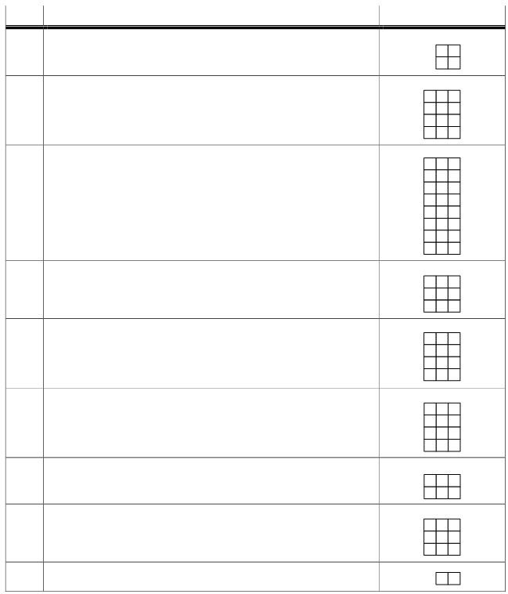

XIV. AGRICULTURE TOOLS

NO. DESCRIPTION NUMBER

1401 Number of land processing tractors
a. two-wheeled tractors … unit
b. four-wheeled tractors … unit

1402 Number of pest controls
a. Sprayer … unit
b. Duster … unit
c. Rats repellent … unit
d.Others … unit

1403 Number of rice processing machines
a. Rice thresher … unit
b. Rice dryers … unit
c. Grain cleaners … unit
d. Huller … unit
e. Rice polisher … unit
f. Small rice mills … unit
g. R.M.U … unit
h. Rice mill plants … unit

1404 number of corn processing machines
a. corn sheller … unit
b. Pemberas jagung (?) … unit
c. corn flour processing machine … unit

1405 Number of cassava processing machines
a. Cassava grater (Pemarut/penyawut ubi kayu) … unit
b. chip maker (Pembuat chip) … unit
c. pellet machine … unit
d. Tapioca mills … unit

1406 Number of rubber processor
a. Non-smoking rubber grinder … unit
b. Smoking house … unit
c. Remiling … unit
d. crumb rubber maker … unit

1407 Number of sugar cane processor
a. With machine … unit
b. Non-machine … unit

1408 Number of fishing boat
a. Motor boat … unit
b. Outboard motorboat … unit
c. Non-motor boat … unit

1409 Number of cold storage … unit

16

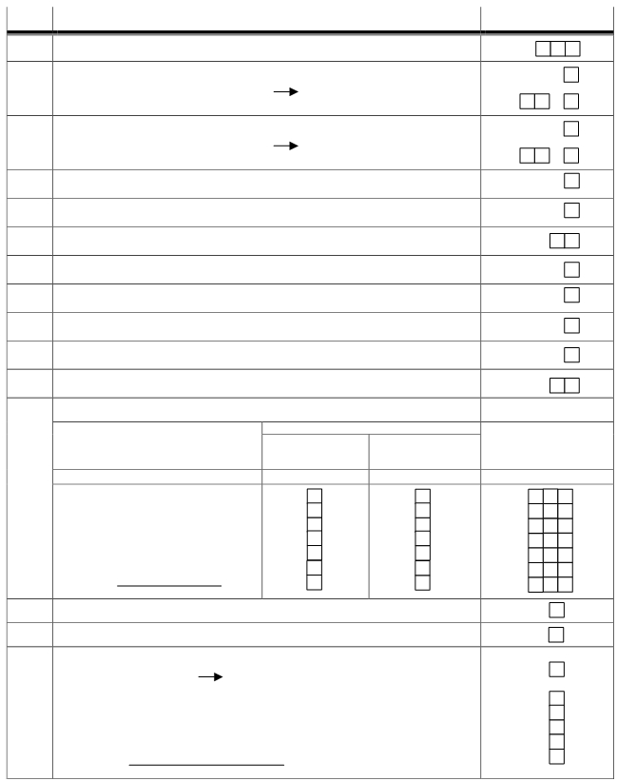

XV. TRADE AND INDUSTRY

NO. DESCRIPTION CODE

1501 Store/Kiosk …….…. unit

1502 a. Store complex:
Yes -1 P1503a No - 2
b. If "No", distance to closest stores ………. km ,

1503 a. Permanent/semi-permanent market:
Yes -1 P1504 No - 2
b. If "No", distance to closest market ………. km ,

1504 Market without permanent buildings: Yes -1 No - 2

1505 Supermarket/mini market: …….…. unit

1506 Restorant/food and beverage kiosks: …….…. unit

1507 Animal market: Yes -1 No - 2

1508 Slaughter house : Yes -1 No - 2

1509 Fish port: Yes -1 No - 2

1510 Fish auction: Yes -1 No - 2

1511 Hotel/Inn: …….…. unit

1512 Small/handicraft industry

Type of industry

Own following type of workers :
Children Women Number of
Yes -1 Yes -1 small/handicraft in
No -2 No -2 industry (Unit)

(1) (2) (3) (4)

a. handicraft from leather
b. handicraft from woods
c. handicraft from metal/precious stones
d. woven/pottery/ceramics
e. handicraft from clothes/weaving
f. Food
g. Others
(specify)

1513 General Bank …… unit

1514 Rural Bank …..….. unit

1515 a. Have residents in this rural/urban village received credit facilities:
Yes -1 No - 2 P1516

b.If “Yes” type of credit:
1. Food Security Credit Yes -1 No - 2
2. Small Business Credit Yes -1 No - 2
3. Home Ownership Credit Yes -1 No - 2
4. Sugar Cane Intensification Credit Yes -1 No - 2
5. Others Yes -1 No - 2
(specify)

17

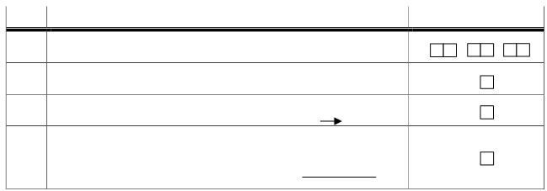
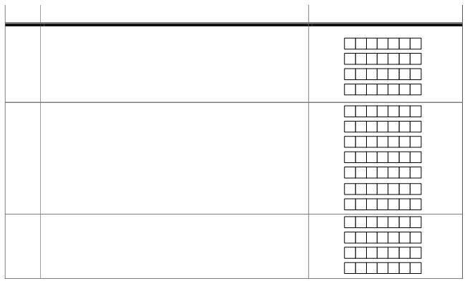
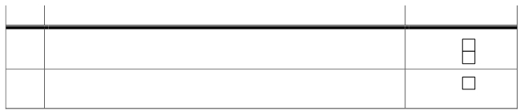

NO. DESCRIPTION NUMBER

1516 Cooperative :
a. Village Cooperative (KUD) …..….. unit
b. Non-KUD Cooperative …..….. unit

1517 this rural/urban village received fuel compensation: Yes -1 No - 2
Not clear -3

XVI. RURAL/URBAN VILLAGE FINANCE (per 31 December 2001)

NO. DESCRIPTION NUMBER

1601 Finance (thousand rupiah):
a. Balance from last year budget Rp. ……………….
b. Income Rp. ……………….
c. Regular monthly expenditure Rp. ……………….
d. Development expenditure Rp. ……………….

1602 Original Village Income (thousand rupiah): Rp. ……………….
a. Rural/urban village land Rp. ……………….
b. rural/urban village market Rp. ……………….
c. Retribution Rp. ……………….
d. Community contribution Rp. ……………….
e. Income from communal works Rp. ……………….
f. others Rp. ……………….

1603 Government supports (thousand rupiah): Rp. ……………….
a. Central Government Rp. ……………….
b. Provincial Government Rp. ……………….
c. District/City Government Rp. ……………….

XVII. POLITICS AND SECURITY

NO. DESCRIPTION CODE

1701 Specify 3 parties with the most votes in the last election
1. …………………. 2. …………………… 3. ………………………

1702 Any political party office in this rural/urban village?
Yes - 1 No - 2

1703 Has any conflict occurred in this rural/urban village in the last one year?
Yes - 1 No - 2 P1705

1704 a. If "Yes", what kind of conflict jenis
Conflict between community groups - 1 Student fights - 3
Conflict between community and
security officers - 2 Ethnic conflicts - 4
Others - 5
(Specify)

18

NO. DESCRIPTION CODE

1704 b. If "Yes", Is the conflict in the last one year:
New conflict - 1 Old conflict - 2
c. Death toll
1) Death …………..… people
2) Injured …………..… people
3) Material (thousand Rupiah) Rp.………………
d. Has the conflict been solved:
Yes - 1 No - 2 P1705
e. If “Yes”, solved by
Communities -1 village staff - 2 security officer - 3

1705 Type of crime in the last one year
Any cases Crime rate compared to last year
(If column 2 =1)
Type of crime Yes - 1 Decreased - 1
No - 2 Similar - 2
Increased - 3
(1) (2) (3)

1. Theft
2. Robbery
3. Looting
4. Abuse/Violence
5. Burning
6. Rape
7. Drugs abuse
8. Murder
9. Others
(Specify)

1706 Any suicide cases in the last one year:
Yes - 1 No - 2 P1707
Suicide victims in the last one year Male Female
(1) (2) (3)

a. Children
b. Teenagers
c. Adults

1707 Efforts by community to maintain security in the last one year
a. Established ecurity post Yes - 1 No - 2
b. Established security groups Yes - 1 No - 2
c. Increased number of security officer Yes - 1 No - 2
d. Screened visiting guests Yes - 1 No - 2
e. Others Yes - 1 No - 2
(specify)
If "No"
1708 Access to reach facility
Very easy - 1
Security facility Yes - 1 Nearest security facility Easy - 2
No - 2 (km) Difficult - 3
Very difficult - 4
(1) (2) (3) (4)

a. Security post ,
b. Police station ,

1709 Number of security officer in this urban/rural village : …………..… people
19


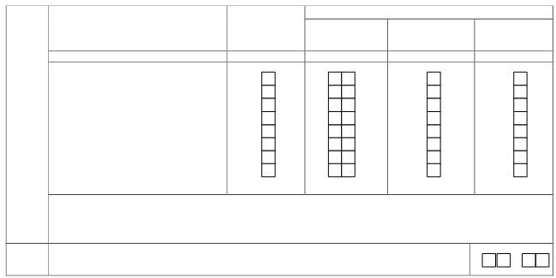

XVIII. INFORMATION ON VILLAGE/KELURAHAN STAFF AND TIME OF CENSUS

If yes (column 2 = 1)
1801 Village/Kelurahan Staff Yes - 1 Sex Highest educational
No - 2 Age Male - 1 degree *)
Female - 2
(1) (2) (3) (4) (5)

a. Head of village /Kelurahan
b. Secretary of Village/Kelurahan
c. Head of Administration Affairs
d. Head of Development Affairs
e. Head of People’s Welfare Affairs
f. Head of Financial Affairs
g. Head General Affairs
h. Assistant to Marriage Registry Officer

*) Eduation Code
Uneducated /Elementary School (SD) Drop-out - 1 Vocational school/equivalent - 4
SD graduate/equivalent - 2 Academy/DIII - 5
Highschool graduate./equivalent - 3 College - 6

1802 Time of census : ……….. Hours, ………. Minute

XIX. NOTES

20

